Chapter 6: Discounted Cash Flow Valuation

- Present Value and Multiple Cash Flows: Seaborn Co. has identified an investment project with the following cash flows. If the discount rate is 10 percent, what is the present value of these cash flows? What is the present value at 18 percent? At 24 percent?

Year Cash Flow
- $ 950
- 1,040
- 1,130
- 1,075

Using formulas and a 10% discount rate:

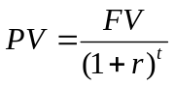

We can also use the ‘stack register’ on a financial calculator:

Using formulas and an 18% discount rate:

We can also use the ‘stack register’ on financial calculators:

Using formulas and a 24% discount rate:

We can also use the ‘stack register’ on our financial calculators:

- Present Value and Multiple Cash Flows: Investment X offers to pay you $6,000 per year for nine years, whereas Investment Y offers to pay you $8,000 per year for six years. Which of these cash flow streams has the higher present value if the discount rate is 5 percent? If the discount rate is 15 percent?

To find the present value of Investment X, an annuity, using a 5% discount rate we use the following equation:

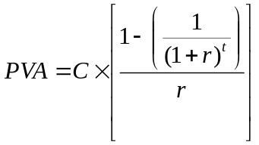

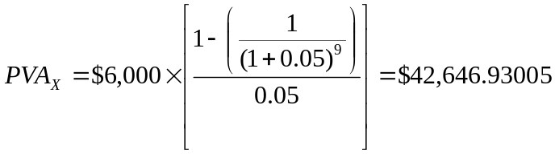

Using a financial calculator:

To find the present value of Investment Y, an annuity, using a 5% discount rate we use the following equation:

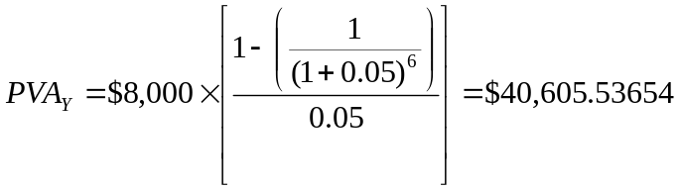

Using a financial calculator:

Using a 5% discount rate, Investment X has a larger PV cash flow stream.

To find the present value of Investment X, an annuity, using a 15% discount rate we use the following equation:

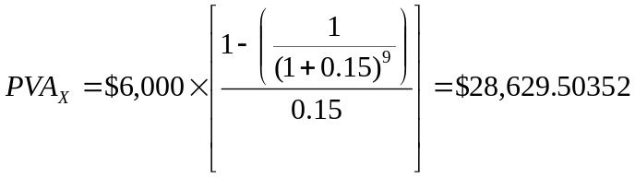

Using a financial calculator:

To find the present value of Investment Y, an annuity, using a 15% discount rate we use the following equation:

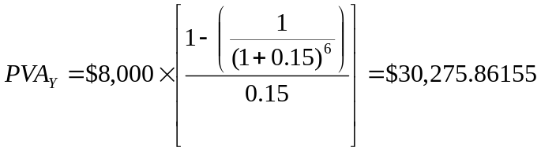

Using a financial calculator:

Using a 15% discount rate, Investment Y has a larger PV cash flow stream.

3. Future Value and Multiple Cash Flows: Paradise, Inc., has identified an investment project with the following cash flows. If the discount rate is 8 percent, what is the future value of these cash flows in year 4? What is the future value at a discount rate of 11 percent? At 24 percent?

Year Cash Flow
- $ 940
- 1,090
- 1,340
- 1,405

Using formulas and an 8% discount rate:

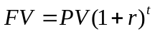

Using a financial calculator:

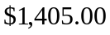
Sum = $5,307.70528

Using formulas and an 11% discount rate:

Using a financial calculator:

Sum = $5,520.96214

Using formulas and a 24% discount rate:

Using a financial calculator:

Sum = $6,534.81056

4. Calculating Annuity Present Value: An investment offers $5,300 per year for 15 years, with the first payment occurring one year from now. If the required return is 7 percent, what is the value of the investment? What would the value be if the payments occurred for 40 years? For 75 years? Forever?

To find the present value of a 15-year annuity using an 7% discount rate we use the following equation:

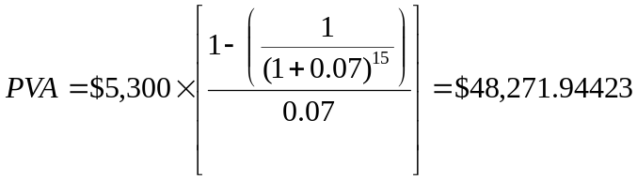

Using a financial calculator:

To find the present value of a 40-year annuity using an 7% discount rate we use the following equation:

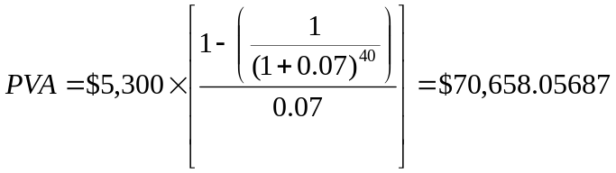

Using a financial calculator:

To find the present value of a 75-year annuity using an 7% discount rate we use the following equation:

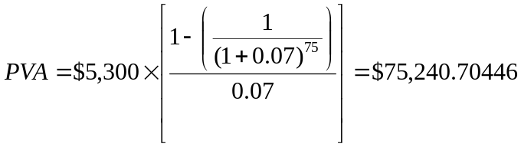

Using a financial calculator:

To find the present value of a perpetuity using an 7% discount rate we use the following equation:

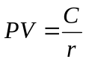

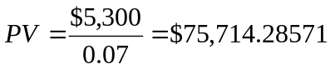

- EAR versus APR: Big Dom’s Pawn Shop charges an interest rate of 30 percent per month on loans to its customers. Like all lenders, Big Dom must report an APR to consumers. What rate should the shop report? What is the effective annual rate?

The APR is simply the interest rate per period multiplied times the number of periods per year. Since the monthly interest rate is 30%, and there are 12 months per year, the APR is:

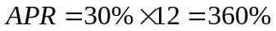

To find the EAR, we use the following equation:

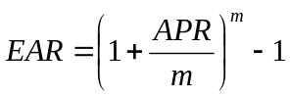

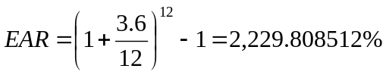

While such an interest rate would be considered above the usury rate for any bank, such rates are common with pay-day loans!

20. Calculating Loan Payments: You want to buy a new sports coupe for $68,500, and the finance office at the dealership has quoted you a 6.9 percent APR loan for 60 months to buy the car. What will the monthly payments be? What is the effective annual rate on the loan?

To find the monthly payment of a 60-month annuity, we use the following equation:

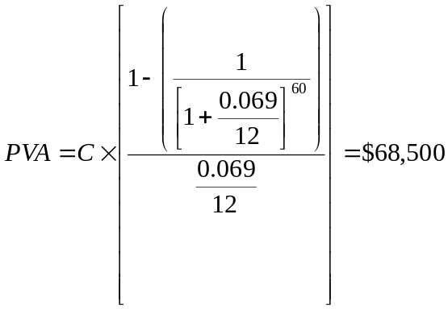

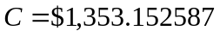

Using a financial calculator:

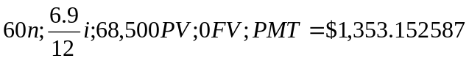

To find the EAR, we use the following equation:

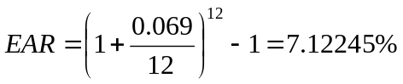

- Calculating EAR: Friendly’s Quick Loans, Inc., offers you “three for four or I knock on your door.” This means you get $3 today and repay $4 when you get your paycheck in one week (or else). What is the effective annual rate Friendly’s earns on this lending business? If you were brave enough to ask, what APR would Friendly’s say you were paying?

First, we need to determine the weekly interest rate using the following future value (or present value) of a lump sum equation:

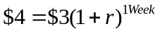

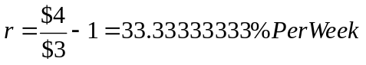

Using the 33.33333333% weekly interest rate, the APR would be:

To find the EAR, we use the following equation:

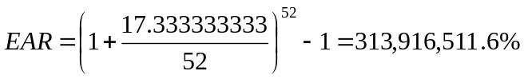

Loan sharks territory!

24. Calculating Annuity Future Values: You are planning to make monthly deposits of $300 into a retirement account that pays 10 percent interest compounded monthly. If your first deposit will be made one month from now, how large will your retirement account be in 30 years?

To determine the future value of an annuity, we use the following equation:

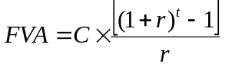

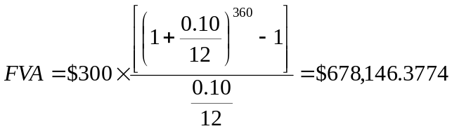

Using a financial calculator:

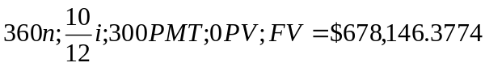

26. Calculating Annuity Present Values: Beginning three months from now, you want to be able to withdraw $2,300 each quarter from your bank account to cover college expenses over the next four years. If the account pays 0.65 percent interest per quarter, how much do you need to have in your bank account today to meet your expense needs over the next four years?

To find the present value of an annuity, we use the following equation:

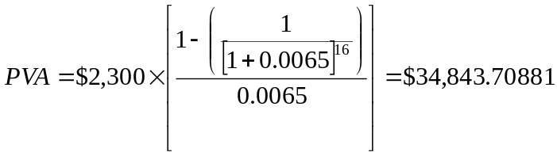

Using a financial calculator:

32. Calculating Annuities: You are planning to save for retirement over the next 30 years. To do this, you will invest $700 a month in a stock account and $300 a month in a bond account. The return on the stock account is expected to be 11 percent, and the bond account will pay 6 percent. When you retire, you will combine your money into an account with a 9 percent return. How much can you withdraw each month from your account assuming a 25-year withdrawal period?

First, we need to determine the future value of the two (stock and bond) annuities:

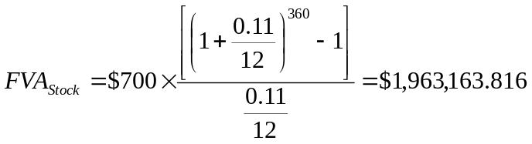

Using a financial calculator:

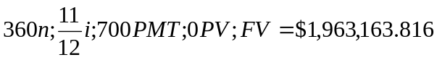

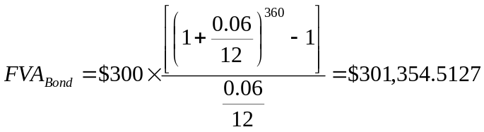

Using a financial calculator:

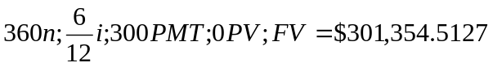

The expected value of the retirement accounts in 30 years is:

Now, we need to determine the monthly withdrawal amount using the present value annuity equation and solving for C:

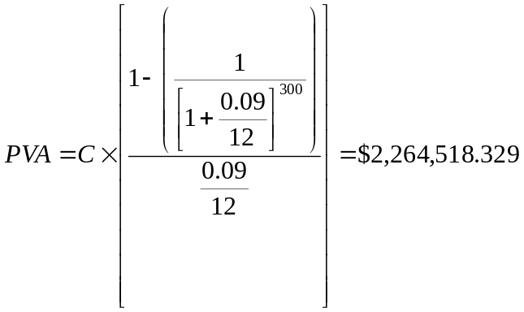

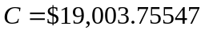

Using a financial calculator:

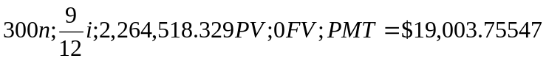

You would be able to withdraw $19,003.76 each month for the next 25 years, after which time your account balance will be almost zero.

34. Calculating Annuity Payments: You want to be a millionaire when you retire in 40 years. How much do you have to save each month if you can earn an 12 percent annual return? How much do you have to save if you wait 10 years before you begin your deposits? 20 years?

To determine the monthly payment, C, we need to save at 12% for 40 years in order to be a millionaire we use the following equation:

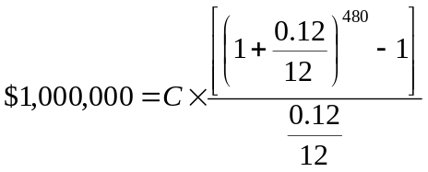

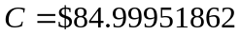

Using a financial calculator:

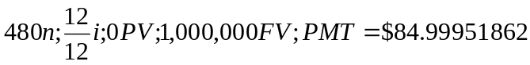

To determine the monthly payment, C, we need to save at 12% for 30 years in order to be a millionaire we use the following equation:

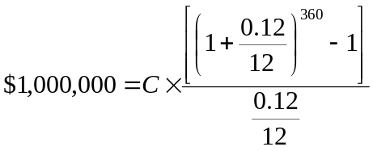

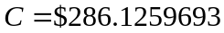

Using a financial calculator:

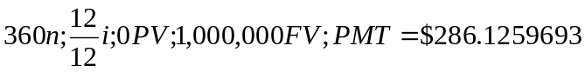

To determine the monthly payment, C, we need to save at 12% for 20 years in order to be a millionaire we use the following equation:

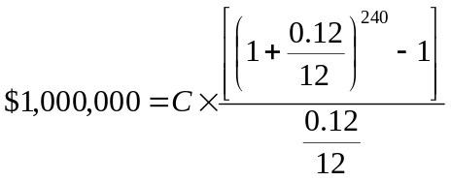

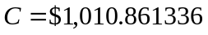

Using a financial calculator:

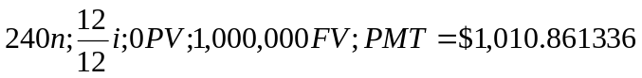

36. Comparing Cash Flow Streams: You’ve just joined the investment banking firm of Dewey, Cheatum, and Howe. They’ve offered you two different salary arrangements. You can have $95,000 per year for the next two years, or you can have $70,000 per year for the next two years, along with a $45,000 signing bonus today. The bonus is paid immediately, and the salary is paid at the end of each year. If the interest rate is 10 percent compounded monthly, which do you prefer?

Since the interest rate is compounded monthly, we need to first determine the EAR:

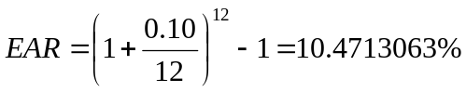

The present value of the $95,000 per year at the end of each of two years is:

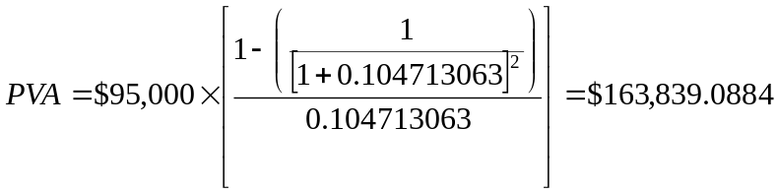

Using a financial calculator:

The present value of the $70,000 per year at the end of each of two years is:

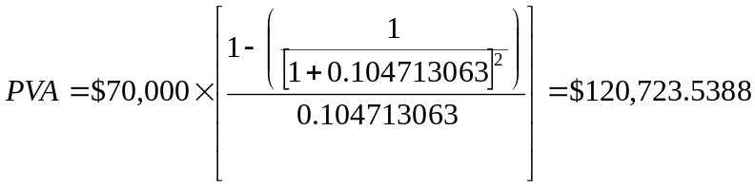

Adding the $45,000 signing bonus received immediately, the value of this contract is:

Using a financial calculator:

The salary contract with $70,000 payable at the end of each of the next two years with an immediate $45,000 signing bonus is more valuable!

38. Growing Annuity: You job pays you only once a year for all the work you did over the previous 12 months. Today, December 31, you just received your salary of $50,000 and you plan to spend all of it. However, you want to start saving for retirement beginning next year. You have decided that one year from today you will begin depositing 5 percent of your annual salary in an account that will earn 11 percent per year. Your salary will increase at 4 percent per year throughout your career. How much money will you have on the date of your retirement 40 years from today?

Since your salary grows at 4% per year, your next year’s salary is:

Therefore, your deposit into your retirement account next year will be:

Since your salary grows at a constant 4% per year and you put in a constant 5% of your salary into your retirement account, your annual deposit into the retirement account grows at 4% per year. Therefore, we can use the present value of a growing perpetuity equation to find the present value of your deposits today:

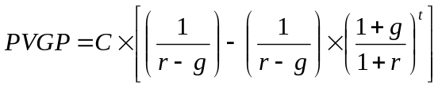

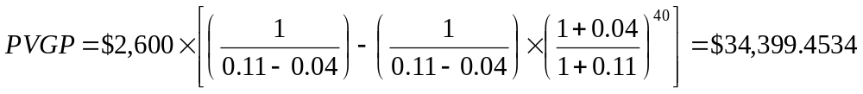

Now, we can find the value of this lump sum in 40 years:

With your amount of your deposit increasing at 4% per year for the next 40 years, and earning a 10% annual rate of return, your retirement account would grow to $2,235,994.306

54. Calculating Annuities Due: You want to buy a new sports car from Muscle Motors for $68,000. The contract is in the form of a 60-month annuity due at an 7.85 percent APR. What will your monthly payment be?

With an annuity due, we simply multiply the value of an ordinary annuity by 1+r. Using the present value of an annuity equation adjusted for an annuity due, we have:

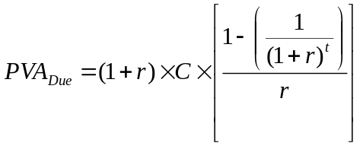

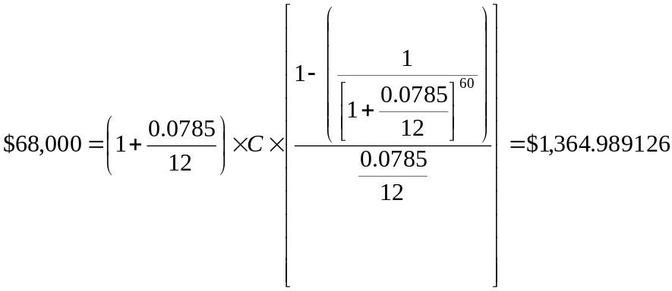

We can also use our financial calculators to solve for the monthly payment of this annuity due. In order to do so, we need to set our financial calculator to the annuity due mode. This requires that we change the annuity from END to BEG (for begin). Once you change the mode, you should see the word BEGIN on the register. Using the annuity due mode we get:

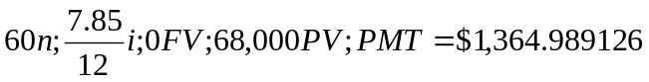

We can also use our financial calculators in the ordinary annuity mode to solve this problem. Once we have obtained the monthly payment for an ordinary annuity, we can simply discount this payment back one period:

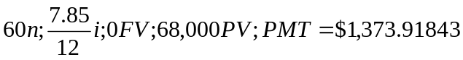

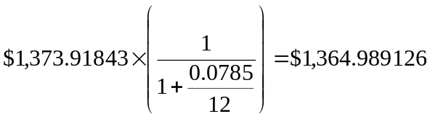

55. Amortization with Equal Payments: Prepare an amortization schedule for a five-year loan of $42,000. The interest rate is 8 percent per year, and the loan calls for equal principal and interest payments. How much interest is paid in the third year? How much total interest is paid over the life of the loan?

Equal P&I payments can be determined using the present value of an annuity equation:

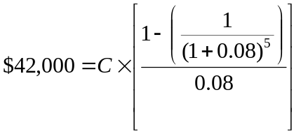

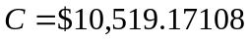

Using a financial calculator:

The interest payment each year is the beginning balance for that year times the interest rate. The ending balance for each year is the beginning balance for that year minus the principle payment for that year. The principle payment each year is the total P&I payment minus the interest payment for that year. The ending balance for one year is the beginning balance for the next year. The amortization schedule is:

Beginning Total Interest Principle Ending
Year Balance Payment Payment Payment Balance
1 $42,000.00 $10,519.17 $3,360.00 $7,159.17 $34,840.83
2 34,840.83 10,519.17 2,787.27 7,731.90 27,108.93
3 27,108.93 10,519.17 2,168.71 8,350.46 18,758.47
4 18,758.47 10,519.17 1,500.68 9,018.49 9,739.98
5 9,739.98 10,519.17 779.19 9,739.98 0

Interest in year 3 is $2,168.71

Total Interest is the sum of the interest payments for all 5 years, which is $10,595.85

56. Amortization with Equal Principal Payments: Rework Problem 55 assuming that the loan agreement calls for a principal reduction of $8,400 (i.e., $42,000/5) every year instead of equal annual payments.

Again, the interest payment each year is the beginning balance for that year times the interest rate. Total payment for each year is the interest payment plus $8,400, the principal payment. The ending balance for each year is the beginning balance for that year minus the principle payment of $8,400. The ending balance for one year is the beginning balance for the next year. The amortization schedule is:

Beginning Total Interest Principle Ending
Year Balance Payment Payment Payment Balance
1 $42,000.00 $11,760.00 $3,360.00 $8,400.00 $33,600.00
2 33,600.00 11,088.00 2,688.00 8,400.00 25,200.00
3 25,200.00 10,416.00 2,016.00 8,400.00 16,800.00
4 16,800.00 9,744.00 1,344.00 8,400.00 8,400.00
5 8,400.00 9,072.00 672.00 8,400.00 0

Interest in year 3 is $2,016.00

Total Interest is the sum of the interest payments for all 5 years, which is $10,080.00

58. Calculating Annuity Values: After deciding to buy a new car, you can either lease the car or purchase it on a three-year loan. The car you wish to buy costs $32,000. The dealer has a special leasing arrangement where you pay $99 today and $450 per month for the next three years. If you purchase the car, you will pay it off in monthly payments over the next three years at an 7 percent APR. You believe you will be able to sell the car for $23,000 in three years. Should you buy or lease the car? What break-even resale price in three years would make you indifferent between buying and leasing?

We can find the present value of each of these two options (buying versus leasing) and compare. Since we are looking at the present value of expenses, the least expensive option is the best.

The present value of leasing is the present value of the leased payments:

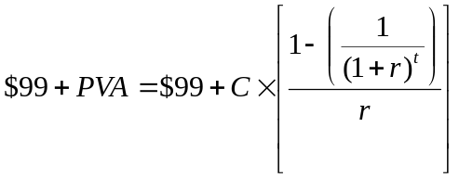
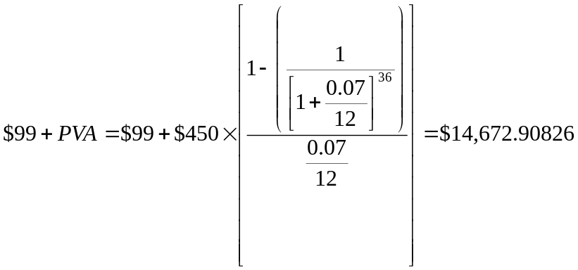

The present value of buying the car is the cost of purchasing the car minus the present value of resale value of the car:

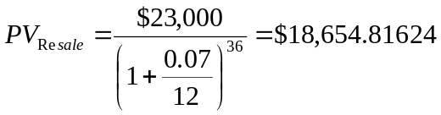

Using the financial calculator:

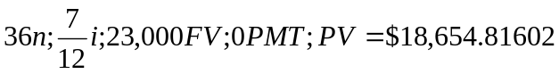

The present value of the buying option is:

Comparing the two options:

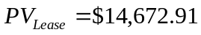

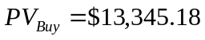

Since the buy option is less expensive, it is the best option.

To determine the resale value that would make us indifferent between the two options, we set the PV of the lease option equal to the purchase price of the car minus the PV of the resale:

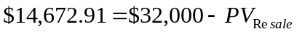

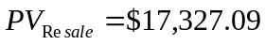

Now, we need to determine what the resale price would be 3 years from now (i.e., the future value):

